Competition Information
Footworks Dance Company
728 Schelfhout Ln
Kimberly, WI 54136

Studio Phone:
920-423-7166

Email:
footworksdancecompany@gmail.com

Student/Parent Portal Link:
https://app.jackrabbitclass.com/jr3.0/ParentPortal/Login?orgId=526866

May 2024 Audition Registration Link:
https://www.footworksdancecompany.com/competition-co-audition-registratio

We recommend dancers auditions at the May group audition time. If you happen to miss our main audition, we take competition company auditions through early August 2024, as space permits, by private audition. Just email us footworksdancecompany@gmail.com.

CONTENTS

- AUDITION DETAILS
- PROGRAM OVERVIEW
- IMPORTANT CLASS INFORMATION
- SUMMER CLASSES
- FEES

AUDITION DETAILS

DATE & TIME:
Footworks Dance Company will hold auditions for the 2024/2025 Competition Company on May 20 & 21 tentative times below.

Age | Time
4 – 7 (Monday) | 5:30 – 6:00 pm
8 & up (Tuesday)(Intermediate Level) | 5:00 – 6:30 pm
12 & up (Tuesday)(advanced Level) | 6:30 – 9:30 pm

WHAT TO BRING TO AUDITIONS:

- A covered water bottle (if desired)
- A completed registration form, unless previously filled out on-line
Link: https://www.footworksdancecompany.com/competition-co-audition-registratio
- Positive attitude and good work ethic

WHAT TO WEAR:

- Hair should be neatly secured up
- No jewelry
- Dance attire: leotard or sports bra with dance shorts (tights or leggings optional)
(clothing must be fitted so we can see your body lines)
- Bring your dance shoes – suggested shoes: tap, jazz, foot undeez, tennis shoes

WHAT TO EXPECT:
You can expect to show various turns, leaps, flexibility moves and moves of control. We will also teach short combinations of choreography and have you show the dance to a panel of teachers. Our goal is to determine your level of dance in various genres.

TEAM PLACEMENT:

Placements on teams are based on age, abilities, technical level, attitude, work ethic, ability to pick up choreography, willingness to try new dance moves and (when applicable) performance last season. All placements are final.

AUDITION RESULTS:

Audition results will be emailed on or before June 15.

After Auditions, we will email results and team acceptance letter. What to do:
Signed contracts are due June 25, along with a $75 Deposit and a $30 registration fee (total due $105). Please log into your portals to make the payment (we will already have the deposit fee and reg fee applied to your account, for your convenience during this process). You can scan your team contract to footworksdancecompany@gmail.com. You may also bring it to the studio during studio hours or mail it to 728 Schelfhout Ln, Kimberly WI 54136. Fees can be paid in your portals or by check or with cash at our front desk.

Failure to return the contract and deposit by June 25 may result in your dancer not being placed on a competition team. The deposit will go towards your dancer’s account/balance and is applied to the last month of tuition due in May, unless the contract has been breached; if the contract is breached, the deposit will go towards any remaining balance on the account, additional administrative expenses and/or the expenses to re-choreograph and re-stage routines.

Please read any paperwork that is sent along with your team info and sign up for summer classes if you have not already done so.

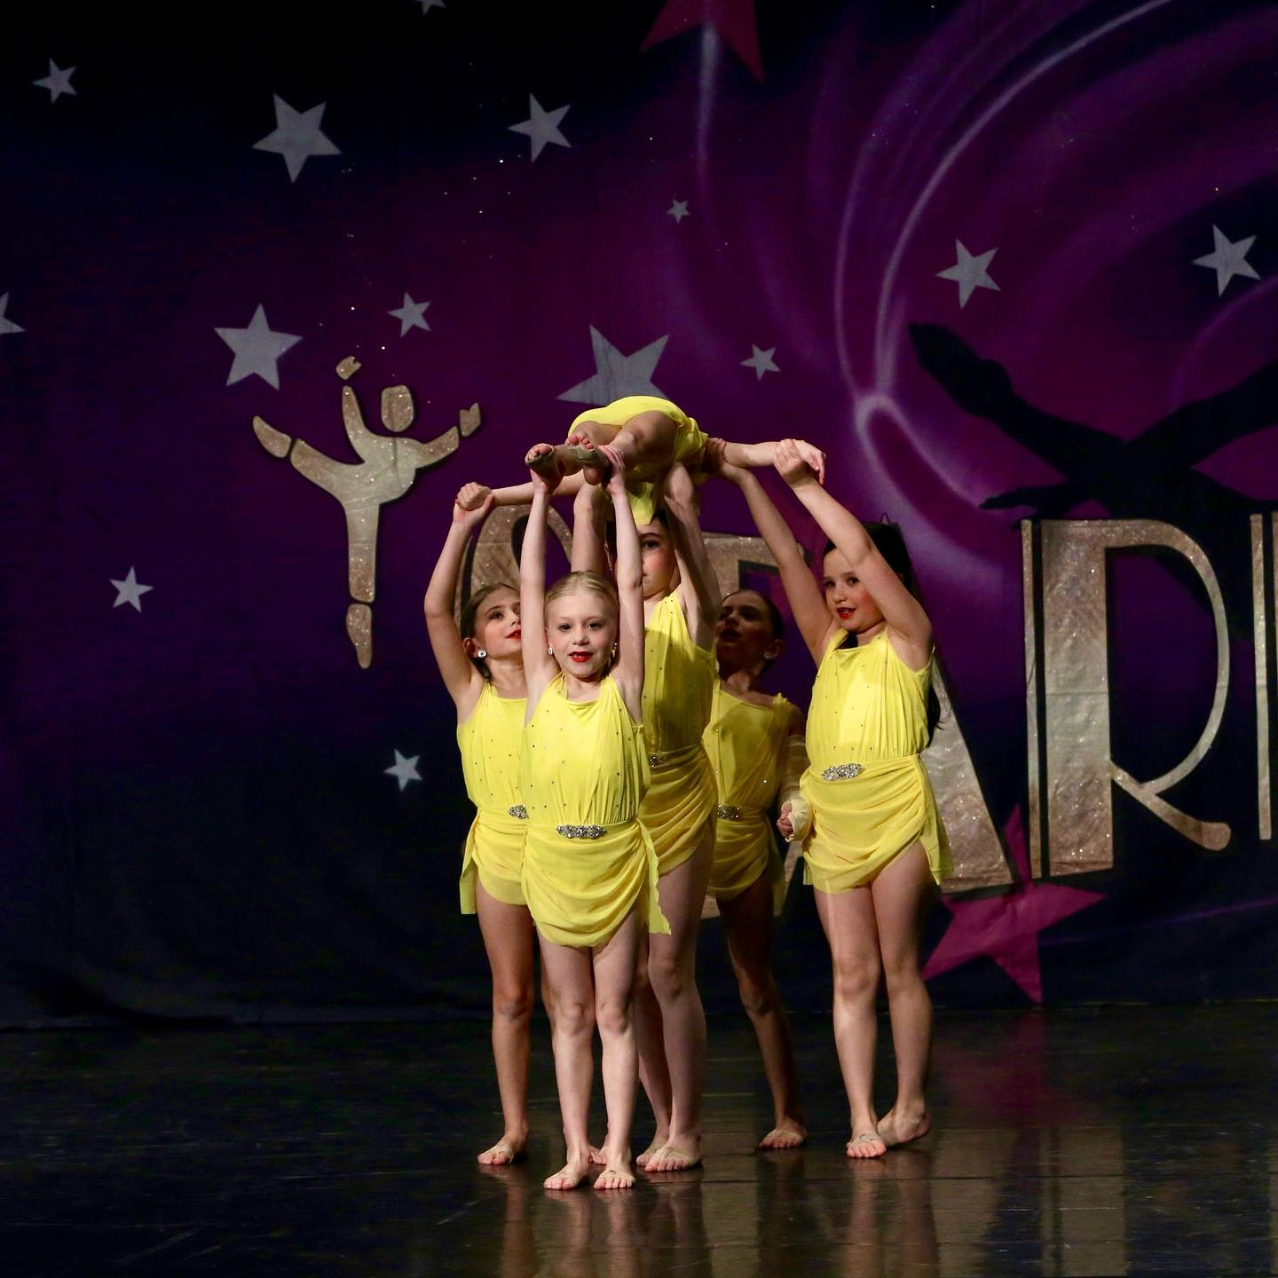
PROGRAM OVERVIEW
Footworks Dance Company is proud to offer a national award-winning competition company program to dancers ages 5 – 19. If you love dance and want to take your dancing to the next level, our competition program is wonderful choice. We aim to provide a culture of team spirit, teamwork, and creativity. Our aim is to help our students become the best dancer and person they can be by exposing them to high quality talent at competitions and engaging them in dance and performance techniques in class.

If you are 5 or older, we welcome you to audition. Competition teams are for students who are passionate about dance, serious about their training, looking for growth and love the idea of being on a dance team. Dancers will adhere to their team contract during the dance season.

Footworks offers several levels of commitment within their competition company, making it a great choice for many dancers. We have teams for young dancers, teams for those looking to compete with 1 or 2 dances and teams for the serious competitor with a higher commitment level.

SEASON
Most Starz and Twinklers dancers will begin their season in September and cumulate their season with nationals in June/July. Their choreography will likely begin when classes begin in September. FDC Elite Dancers may begin some choreography (select dances) in August and cumulate their season with nationals in June/July. The competition dance commitment runs from August to July. Dancers must participate in at least 1 summer class or camp. During the season, dancers will participate in the “Winter Showcase” in December, the “Spring Recital” in May, Regional Competitions (January – May) and a National Competition in June/July. We also hope to participate in a seasonal parade (more information to come). Dancers will be given opportunities to attend a convention(s) during the season. Look for details on conventions listed under your team information.

Starz and Twinklers will participate 2 - 4 mandatory regional competitions and FDC Elite dancers will participate in 3 – 5 mandatory regional competitions. Please look for more details when competitions are scheduled on the calendar. Select groups and soloists may be invited to participate in additional competitions throughout the season. You can expect regional competitions to be in Green Bay, Milwaukee, Madison, Chicago and other cities in Wisconsin, Illinois and Minnesota. You can anticipate all regional competitions to be within about 3 ½ hours from Kimberly.

Nationals will be in June/July. More information will come as the calendar is completed.

CLASS INFORMATION
ALL Competition dancers must participate in at least 1 ballet class. Teachers will automatically place dancers in the appropriate level class upon registration to FDC Competition Company. FDC Elite Dancers must also participate in at least 1 technique, stretch and strength class. Any dancer 8 and up is eligible to take a technique class, and this is highly recommended. To be eligible for a solo or duet/trio, dancers must be approved at auditions and participate in at least 1 group competition routine. Solos/duets are limited and will be listed on your audition form if eligible. Dancers may take more than 1 ballet class or more than 1 technique class.

SUMMER CLASSES:
All competition company dancers must enroll in a summer class or camp at FDC. FDC Platinum Elite Dancers must enroll in the Advanced Summer Camp that is held in the summer. We recommend FDC Elite Gold dancers to enroll in the Intermediate Summer Camp. Other Competitive dancers can enroll the summer classes or camps of choice.

MORE CLASS INFO….

CLASS DAYS, LENGTH, SCHEDULE, CALENDAR INFO
Fall group competitive classes meet Monday, Tuesday , Wednesday or Thursday evenings during the week. An occasional weekend rehearsal may occur during the season. Look for an upcoming schedule to be sent out for your regular class times. Duets/Trios meet once every third week for 30 minutes. Solos meet once every third week for 30 minutes. Solos and duets can utilize empty studio space to rehearse, as available and with approval from the front desk. Bunheads is 30 minutes, Tappers and Tutus is 1 hour and Ballet 1 is 40 minutes. Ballet 2, 3, 4 & 5 all meet for 50 – 60 minutes. Technique classes will meet for 30 – 45 minutes. Twinklers Tap & Lyrical meet for 1 hour rehearsing both styles of dance. All other competition classes meet 35 – 50 minutes each.

SEASON AND CALENDAR INFO
Fall classes are tentatively scheduled from September 9 to our recital week. (Sept – May anticipated session about 32 weeks). In addition, all teams attending nationals can expect to meet 2 – 3 times for national rehearsal classes in June (look for this calendar in spring). Most teams attend nationals. Select FDC Elite teams will meet in August to begin choreography (look for more info to come). Most Twinklers and Starz groups will likely begin choreography in September when regular fall classes begin, but double check emails.

We will NOT have dance classes during the week of Thanksgiving and we will take 1 week off for Spring Break, along with 2 weeks off for Christmas/New Year’s. Please note: No classes will be held on October 31 (Halloween) however, classes are scheduled as normal the rest of this week.

FDC follows the actions of the Kimberly School District during inclement weather. In the event of inclement weather or an emergency where classes are cancelled, dancers can look to our video resources for an at-home class/practice as make-up. FDC Company dancers may also attend any technique class during the week or month following a cancellation as a make-up class.

ABSENCES
Competition Dancers are allowed 5 absences throughout the season. Tardiness over 5 minutes counts as a partial absence. Competition classes held the week of a competition are mandatory. Only 1 absence is allowed in the month preceding a competition. (if you have special circumstance, please see the director for prior written consent). Doctor’s notes will be considered excused, however, if you are not contagious, you are expected to come to observe competition classes if possible. If you are out with an injury or illness for an extended period of time, you will need to know the dance thoroughly before being approved to compete again and strong enough to perform all skills expected in the routines. Make-up classes and at home practice should be expected in these circumstances. Director approval will be required to return to competitions.

MAKE-UP & HAIR
Prior to the competitions beginning, dancers will need a specific supply and make-up. Dancers will also be given a studio hair style to be worn at competitions.

ATTIRE
During classes, hair should be neatly secured back. All dancers should wear form fitting dance attire to ALL classes, such as: leotards, sports bras, dance shorts and/or tights. All dancers will need a black leotard or sports bra & black shorts, along with a nude leotard or sports bra and nude shorts. They should carry these in their dance bags to all competitions just in case they are needed. These items can be worn for regular classes as well.

COSTUME FEES
You should anticipate that total costume fees will be due in late September. Costumes will cost between $69 - $125 per class (most costumes for competition are $79 - $95).

ADDITIONAL FEES & REQUIREMENTS
All competition dancers will need rhinestone earrings ($10 - $15) that are available at our front desk. Competitors will need specific shoes for their classes (prices vary). Shoes will be determined in the fall. All competition dancers will need a team jacket or Footworks apparel for cover-ups at competitions and for awards (coat $80 - $90 approximately). Additional accessories and tights may be required. Competition fees will be assessed for each competition and due in a timely manner. Most group fees range between $65 - $95 per person per competition. Most competitions also charge media fees ranging from $25 - $50 per person per competition, which gives you access to your dancers photos and videos. Solo competition fees usually range from $130 - $180 per competition. Duet/trio competition fees usually range from $75 to $115.

COMPETITION COMPANY TUITION 2024/2025 –
Enrichment classes are schedule for approximately 31/32 weeks between September and May. Competition Groups meet for 2-3 extra rehearsals in June in preparation for Nationals. A few select groups will have choreography in August. An occasional extra practice may be scheduled for competition groups. No fee required for auditions. Costumes and Competition fees billed separately.

ALL - Ballet –  choose 1 | Annual Payment | Semester  Due before Sept 9 | Semester  Due Jan 1 | Monthly  9 payments – Sept - May
Bunheads  Age 4 – 6 only | $316 | $161 | $161 | $39
Ballet 1,2 – AGE 6 & UP | $389 | $197 | $197 | $49
Ballet 2, 3, 4/5, 5/6 | $429 | $220 | $220 | $55
Tappers & Tutus  Age 4 & 5 only | $429 | $220 | $220 | $55

Twinklers  AGE 5 - 9 | Annual Payment | Semester  Due before Sept 9 | Semester  Due Jan 1 | Monthly  9 payments – Sept - May
Tap & Lyrical Troupe | $610 | $310 | $310 | $76

Starz Troupe – 7/8 & UP  All - Lyrical Troupe  Optional: Tap, Jazz, Hip Hop Co | Annual Payment | Semester  Due before Sept 9 | Semester  Due Jan 1 | Monthly  9 payments – Sept - May
Lyrical Troupe | $397 | $203 | $203 | $50
2 companies | $772 | $396 | $396 | $97
3 companies | $1126 | $578 | $578 | $142
4 companies | $1458 | $749 | $749 | $179

FDC Elite  All Lyrical, Jazz, Perform Co  Optional Co groups: Tap, Hip Hop, Modern Co, Or Enrichment Pointe (Platinum must choose 2 options) | Annual Payment | Semester  Due before Sept 9 | Semester  Due Jan 1 | Monthly  9 payments – Sept - May
4 companies | $1458 | $749 | $749 | $179
5+ Groups  Platinum starts here | $1792 | $931 | $931 | $228 1st due Sept 1
Unlimited Groups  Early Bird due July 10  5+ Co groups to qualify plus unlimited ballet & unlimited Tech & unlimited enrichment.  *solos and duets charged separately | $2275  early bird due July 10 | $1225  early bird due July 10 | $1225  Due July 10 | $299  1st payment early bird must be paid by July 10 to qualify

TECHNIQUE & CONDITIONING  ELITE MUST CHOOSE TECH,  8 & UP OPTIONAL, NONE 7 & UNDER | Annual Payment | Semester  Due before Sept 9 | Semester  Due Jan 1 | Monthly  9 payments – Sept - May
Tech/conditioning | $252 | $131 | $131 | $32

Solos &  Duets/Trios - OPTIONAL | Annual Payment | Semester  Due before Sept 9 | Semester  Due Jan 1 | Monthly  9 payments – Sept - May
Solo | $270 | $137.50 | $137.50 | $32
Duet/Trio per person | $210 | $107.50 | $107.50 | $25

Enrichment - Optional | Annual Payment | Semester  Due before Sept 9 | Semester  Due Jan 1 | Monthly  9 payments – Sept - May
30 min enrichment | $252 | $131 | $131 | $32
40/45 min enrichment | $308 | $159 | $159 | $40
50 min – 1 hr enrichment | $338 | $174 | $174 | $45

COMPETITION COMPANY/TEAM CONTRACT
A $30 registration fee and a $75 deposit are due after auditions to register for the FDC Competition Company. All audition decisions are final. Your company/team commitment is from August 2024 to July 2025 (nationals). Initial costume fees are due in September (solo costumes must be ordered by mid-October to ensure on-time delivery) and national competition fees are due in the spring. All regional competition fees will be due at least 45 - 60 days prior to competitions. Look for more information to come on regional fee payments. Once registered, your spot on our competition company is reserved for you for the entire season (Aug to July), and full tuition, costume & competition fees (for regionals and nationals) will be due (regardless of the number of classes attended). Students are expected to meet attendance requirements and all fees are to be paid in a timely manner. Monthly tuition payers will be on auto pay and any fees remaining (with the exception of nationals), will be automatically charged to the card on file in early May. Footworks does not offer refunds. Students are expected to attend all mandatory regional and national competitions and group performances. Please read the studio handbook and welcome letter. Failure to comply or breach of contract may result in suspension or removal from a team/company or other disciplinary actions may be enforced.

Participation on a competition company/team is privilege, not a right. Instructors and/or the Studio Director have the final say in any and all matters concerning these groups.

INITIALS Company/team dancers have read, understand and agree to the following participation guidelines upon their registration and team acceptance:

_____ We will be committed to our team from AUGUST 1, 2024 to July 31, 2025, putting forth our best efforts to meet the demands and requirements as set forth by Footworks Dance Company. All practices and performances will take place at Footworks studio or at studio sponsored events.

_____ Regular attendance and participation in classes is required by all company/team members. Members must maintain 85% attendance throughout the year. Tardiness is counted as a partial absence/demerit. Absences exceeding those mentioned will require make-up classes at the availability of the instructors, at the cost of $35 per half hour session. Failure to comply will result in suspension from competitions and may involve removal from the company/team without refund or account credits. Please keep in mind, instructors may not have make-up times available during competition season. If you have an extenuating circumstance for absences, please be sure to receive prior written director approval or doctor’s notes. When possible, injured/ill dancers should observe class. Dancers are allowed 1 absence the month of a competition and attendance during classes the week of a competition are mandatory.

_____ All tuition, costume, and competition registration fees, as well as any other related fees and expenses, are required to be paid in full by the dates set by Footwork Dance Company. All payments are the sole responsibility of the company/team member. Failure to comply will result in suspension from competition. I agree that I have read the policies on payments, late fees, and refunds. Footworks does not offer refunds. Account tuition credits are available on a prorated basis only, for dancers with a serious medical condition accompanied by a doctor’s signed statement of your inability to dance.
_____ Competition company/team members must follow the Footworks Dance Company dress code at all times. Dress code is not solely attire, but includes wearing appropriate shoes at all times. Your instructor will let you know of their specific requests and guidelines on attire. For example, some jazz/lyrical instructors may approve you to dance barefoot. Tight, form fitting clothing, such as leotards, sports bras and dance shorts are required. Students coming to class not properly dressed may receive a ½ absence/demerit for each class.

_____ Competition Company/team members are expected to set an example in technique and performance in all classes. Students are expected to give 100% effort during all class periods. Students not performing to the best of their abilities may receive a ½ absence at the discretion of the instructor.

_____ Participation in ballet for ALL company dancers and technique for FDC Elite Dancers, is required of competitive dancers in accordance with their team requirements. Additional ballet, pointe and technique classes are offered to all company dancers. Please see your instructor, the front desk or the director regarding specific company/team requirements. Company/Team members must enroll in at least 1 summer class or camp in accordance with their team guidelines. We recommend Stars and Twinkler Company Dancers take technique but is NOT required for these dancers.

______ Ballet Class Info and Attire:
Ballet Attire: Hair is to be neatly secured up, ballet shoes worn, leotard and tights (ballet skirt optional – no additional cover-up, unless specified by instructor)
Note: Ballet 5/6 (Thurs), Ballet 2 (Tues) - The 2 listed ballet classes will strictly enforce the attire policy and dancers will NOT be allowed to participate in class if not in the correct attire. These 2 classes are designed for those serious about ballet and getting the most out of their ballet classes (note: the instructor has the final say on attire for any class) (If the dancer is habitually in the wrong attire, we will automatically place them in a more appropriate ballet class for their personal desires, which may be at the expense of an additional costume, therefore choose your ballet class time accordingly)

_____ All company/team members must have or purchase an official team jacket and competition earrings. FDC apparel is to be worn as a cover-up when not dancing and during awards. Ordering information will be made available in the fall.
Competition dancers will be required to purchase shoes for their class. Dancers will need a supply of nude and black garments (leotard, sports bra, shorts).

_____ Competition company/team members and their family and friends are never to degrade another dancer. We will not make degrading comments on a dancer’s ability, performance, appearance, personal attributes, or personality. Bullying will not be tolerated in person or through technology. We are representing the studio, whether we are on or off the stage, and need to do so with professionalism and good sportsmanship. We will work to spread positivity at competitions to our teammates and fellow dancers from other studios. Working as a team is required of all Team members. Failure to work together as a team in accordance with the director, studio and instructor’s guidelines may result in suspension or removal from a team. BE NICE! Further, FDC competition company dancers will show respect for their teachers, studio parents and fellow teammates.

_____ Participation in scheduled regional competitions is required of competitors. Participation in nationals (as determined in the spring) is required of selected teams. Most groups will attend nationals. If any dancer is unable or unwilling to compete for any reason at regionals or nationals, other than those accompanied by a doctor’s note or prior written consent, will be subject to a re-choreography fee of $100.00 per dance and for any substitute dancer’s competition fees and and will loan their costume to any replacement dancer for free for competitions and mayl be suspended from future competitions or the entire company, without refund or credit, at the director’s discretion. We will always listen to extenuating circumstances before making a final determination on suspension or team removal, for example, a close family member’s funeral will constitute extenuating circumstances.

_____ COMPETITION COMPANY FEE SCHEDULES AND PAYMENT DUE DATES: Fall tuition fees are due in full for the entire session/season in accordance with your payment option due dates, Costume deposits/fees are due in September, Regional competition fees are due on the designated dates. If dancers do not pay their competition fees in a timely, dancers will not be registered for competitions. (see payment options), National Competition fees are due in spring (on a designated date to be announced).

_____ I have read, understand and will abide by the studio policies available on the Footworks website. I have read and agree to my FDC Competition Company requirements.

_____ I have read, understand and will abide by the studio policies available on the Footworks website. I have read and agree to my FDC Competition Company requirements.

_____ A competition meeting will be scheduled In the fall and you/parent should make every effort to attend this meeting. If we cannot attend, we will see the director personally and receive the information provided.

Parent Signature _______________________________________________________ Date ____________________________

Student Signature _______________________________________________________

AUDITION REGISTRATION

Name ________________________________________________

Birthdate ___________________

Email ________________________________________________

Phone _____________________

Address ________________________________________________
________________________________________________

ARE YOU INTERESTED IN A SOLO? __________________

ARE YOU INTERESTED IN A DUET/TRIO? ____________________

Please CIRCLLE which applies to you:
RECREATIONAL | INTERMEDIATE | SERIOUS
2 – 5 classes per week  1 ½ to 5 hours | 4 – 8 classes per week  2 ½ to 7 hours | 7 or more classes  5 + hours a week
Minimal extra practices | Occasional extra rehearsals are ok | Extra practices are ok
Fun, friendships and learning experiences to help me grow are important to me | Looking for a happy medium of friendships, fun, technique and learning experiences, willing to work hard in my classes | I want to work to my highest potential and surround myself with other serious dancers, dance is my priority extra-curricular
 | Would like optional conventions offered to me | Willing to attend a required convention

PLEASE CIRCLE COMPETITION CLASSES THAT YOU MAY BE INTERESTED IN:
PERFORMANCE CO, JAZZ & LYRICAL ARE REQUIRED IN FDC ELITE GROUPS

TAP * JAZZ * LYRICAL * HIP HOP * MODERN * XTRA LYRICAL OR JAZZ CO * PERF CO

I understand dance is physical activity and do not hold Footworks Dance Company by Kim LLC liable for any injuries.

Signature ________________________________________________ Date _______________

Competition Company Registration
(to be completed after auditions when teams are announced)

Link to register:
https://docs.google.com/forms/d/e/1FAIpQLSdiX__ROPxbCWRm9OE8Fk8JV5kB1a0DtMKbPjWwL5RePBSddA/viewform?vc=0&c=0&w=1&flr=0

