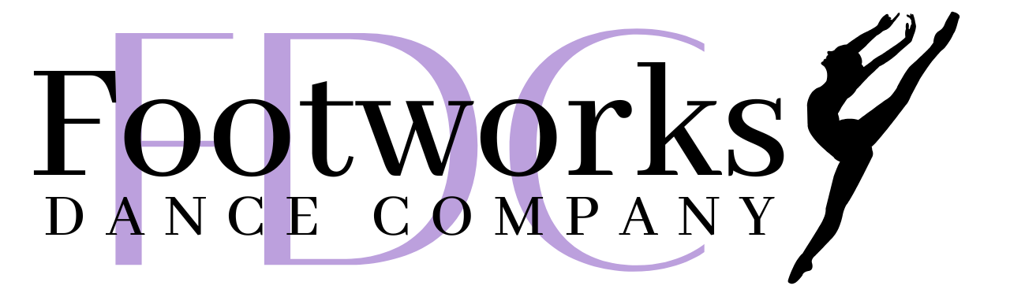

FOOTWORKS DANCE CO CALENDAR 2025/2026
Purple is for Competition Company Dancers Only –

Now
Costume Measurements & Payments – costume payments are due the week classes start
Automatic monthly tuition – if you are monthly tuition payer, tuition and registration fees will be billed the week classes begin

November
Nov 7 – 9 - CNADM – Chicago Dance Convention – optional
Nov 21 – 23 – DMW – Chula Vista Dance Masters WI Convention - optional
Nov 25 – Appleton Christmas Parade - Tentative – Waiting on confirmation
Nov 24 – Nov 30 - No Classes Thanksgiving Week – Tentative Monday Competition Teams Practices Nov. 24
Nov 25 – Appleton Christmas Parade – See the front desk for more information
December
Dec 3 – Radix Convention Registration Deadline –
Dec 4 – Applause Solo/Duet/Trio Competition fees Due
Dec 15 - 18 – Family Watch Week at the studio – Adopt a Family - more information to come
Dec 19 - Jan 4 - Winter Break (No Classes) (ALL comp teams will have classes Mon Dec 22 & Tues Dec 23 – Oct make-up)
Dec 31 – Applause Solo/Duet/Trio Competition fees Due
Dec 31 – Groove Competition Fees Due

January
Dec 22 - Jan 4 - No Classes
Jan 5 – Classes resume
Jan 20 - 23 - Glow Dance Party Week – wear your fun fluorescent colors
Jan 26 – Triple S Competition Fees Due
Jan 30 – Feb 1 – Radix Convention – optional
February
Feb 1 – Rainbow Competition Fees Due
Feb 12 – Breakout Competition Fees Due
Feb 16 – 19 – “I Love Dance” week – wear purple, pink, red or white this week to celebrate loving dance
Feb 20 – 22 – Applause Competition Milwaukee
March
March 20 – 22 – Groove Competition – Oregon WI
March 30 – April 5 – No Enrichment Classes – Spring Break- Comp Co rehearsals March 30 & 31- Oct Make-up
April
March 30 – April 5 - No Enrichment Classes – Spring Break * Competition team practices March 30 & 31 –
April 1 – National Competition Fees due
April 6 – 9 – Parent Appreciation Week -
April 9 – 12 – Triple S Competition – Green Bay/Neenah area *Note Thursday start
April 17 – 19 – Rainbow Dance Competition - Milwaukee
April 13 – 16 – Dance Pictures at Footworks with Debbie Daanen
May
May 1 – 3 – Breakout Dance Competition – Madison
May 12 and May 14 – Mandatory Rehearsals (Tues & Thurs) at Kaukauna High School (schedule to come)
No classes at the dance studio this week
May 16 - Footworks Dance Recital at Kaukauna High School (look for info to come)
May 18 and May 19 – 2026/2027 COMPETITION COMPANY AUDITIONS
May 26 – Summer Classes Begin – Session 1 begins May 26, Session 2 begins July 8, Camp Week Begins June 2

June
Nationals June 14 – 18 for FDC Competition teams in WI Dells
June 25 - 2026 Competition Registration and Deposits Due

