Dance Rehearsal Expectations
- Please understand that every dancer at Footworks has to attend a mandatory dress rehearsal in order to perform on the recital. This helps each dancer and parent understand the order and structure of the show. Mandatory dress rehearsals will be held on TUESDAY, MAY 16TH at Kaukauna High School.
- Please drop off your child on time! We will not be able to wait on dancers who are late, as we need to run on time, in order to stay on schedule. Dancers should check in with the auditorium attendant and a Footworks helper will assist them to the backstage/auditorium area.
- Please look carefully at your rehearsal schedule for all your appropriate times. Your child should arrive in costume, with hair neatly secured up, and make-up complete.
- PARENTS WILL NOT BE ALLOWED IN THE AUDIENCE DURING REHEARSAL
- Dancers will be brought out to the lobby as soon as they are finished performing their last routine in their allotted time block. Many dancers have multiple allotted time blocks. They are allowed to go home when they are done rehearsing.
- If your dancer finishes ahead of their scheduled end time, a Footworks helper will notify you via email or text (if available).
- Children will be FULLY supervised in the backstage/auditorium are for the entire duration of the rehearsal and recital. The same volunteers will stay with each class during the rehearsal and the recital and remain with the class until every child is picked up on both days. Your child’s safety in very important to us. Please help keep all our students safe by respecting and following these rules.

If you have any further questions regarding dress rehearsals, please contact the studio before rehearsal/recital events. Thank you!

RECITAL INFORMATION
- The recital is Saturday, May 20th at Kaukauna High School. There will be two separate Acts. Act 1 begins at 2:15 pm and will showcase Footworks Solos and Duets. Act 2 begins at 3:30 pm and will showcase Footworks Enrichment Academy Dancers, Footworks Shooting Stars Dancers, Footworks Competition Company Group Dances and Senior performances. We anticipate the entire show to be done around 6 pm.
- Dancers will need to be in their dressing room, ready to dance with their hair and make-up complete 30 – 40 minutes prior to show time. Please allow extra time to arrive at the school. Costume, hair and make-up often take longer than expected. If you child is rushed or late, this may cause them to be frazzled on stage and unable to perform their best.
- Please remain seated during the performance as much as possible. If you have a young child or need to get up for health reasons, please purchase tickets at the end of an aisle.
- The auditorium doors will open for the first Act at 2 pm and it is anticipated to run about 45 - 50 minutes. We will take an intermission break between the two Acts. At this time, auditorium doors will open to new guests and offer a break before Act 2 begins. Auditorium doors for Act
2 will open shortly after 3 pm. Act 2 will begin at 3:30 pm and have a brief 10 minute intermission. Act 2 is anticipated to be approximately 2 1⁄4 to 2 1⁄2 hours.
- For the safety of our dancers, videotaping and flash photography are strictly prohibited during the performance.
- During the recital, please remember that there is no coming and going. No dancers will be released at intermission or at any other time throughout the recital. Immediately following the show, send one guardian to pick your dancer up in their dressing room.
- Finally, we invite you to slow down and enjoy the day with your family. A dancer’s participation in the show is much more than the time spent on stage. It is a whole experience, an opportunity to share something with loved ones and a chance to celebrate a huge accomplishment. It is a time spent with dance friends making wonderful memories.
If you have any further questions regarding the recital please contact the studio before rehearsal and recital event. Thank You!
BACKSTAGE ETIQUETTE AND TIPS
- SEND A DRY SNACK AND WATER WITH YOUR CHILD TO THE RECITAL – FOOTWORKS WILL ALSO PROVIDE A DRY SNACK AND WATER FOR DANCERS AT THE SHOW.
- PLEASE SEND YOUR CHILD WITH A SMALL BAG CONTAINING BOOKS, COLORING OR AN ACTIVITY. THIS IS EXTREMELY HELPFUL FOR OUR YOUNGER DANCERS. FOOTWORKS WILL PROVIDE COLORING OPTIONS AT THE SHOW.
- PLEASE BE SURE TO SEND A NOTE WITH YOUR CHILD CONCERNING ANY ALLERGIES OR MEDICAL CONDITIONS HE/SHE MAY HAVE.
- DANCERS’ NAMES SHOULD BE ON ALL THEIR BELONGINGS AND SENT IN A BAG. DANCERS SHOULD HAVE ALL COSTUMES, HEADPIECES AND SHOES WITH THEM FOR THE REHEARSAL AND RECITAL.
- FOOTWORKS IS NOT RESPONSIBLE FOR ANY ITEMS LEFT AT KAUKAUNA HIGH SCHOOL. ANY ITEMS THAT ARE LEFT IN THE DRESSING ROOMS WILL BE DISCARDED FOLLOWING THE REHEARSAL OR SHOW.
- DANCERS ARE EXPECTED TO REMAIN IN THEIR DRESSING ROOM DURING THE RECITAL. DURING THE REHEARSAL THEY WILL BE EXPECTED TO REMAIN IN THE DESIGNATED SEATING AREA WHEN NOT PERFORMING.
- NO BRIGHT NAIL POLISH, JEWELRY OR ACCESSORIES THAT ARE NOT PART OF THE COSTUME SHOULD BE WORN AT REHEARSAL OR RECITAL.
- PLEASE AVOID UNDERWEAR UNDER TIGHTS/COSTUMES, AS IT CREATES LINES AND BUMPS AND CAN BE VISIBLE UNDER THE LIGHTS. SPECIAL NUDE UNDERGARMENTS CAN BE ORDERED ONLINE. PLEASE SEE THE FRONT DESK IF THIS IS OF INTEREST TO YOU.

Costumes, Hair and Make-up
Our website, www.footworksdancecompy.com, will offer specific requirements for shoes and tights, along with more detailed information. Use the “recital & tickets” tab.

Costumes should never be ironed, as the heat is too much for the sensitive fabrics. Instead, use a steamer, or hang the costume upside down on a hanger and place it in the bathroom when taking a hot shower. When storing tutus, upside down on a hanger is a great way to keep them full. Remember to keep your costumes in a safe place. Costumes take many months to come in, as they are made to order (sometimes as much as 5 or 6 months for delivery), therefore ordering a new costume is not option. Keep this in mind when ordering your size in the fall, as well.

All dancers, regardless of age, will need light make-up and lipstick. The stage lights are very bright, and dancers will appear “washed out” without make-up. Your teacher will let you know how to wear any accessories. Dancers will need to check their shoes and tights chart (available in emails and on the website). Many classes need tights (the Balera brand is required) and most classes need specific shoes.

ALL dancers will need to have their hair in some sort of “up do”. A low pony with bangs secured back, is a great option for all dance genres. A bun is a great choice for ballet dancers.

Volunteers
Limited volunteer opportunities are available at our recital. For inquiries on volunteering, please stop by our front desk. For volunteer responsibilities, please go to our website at www.footworksdancecompany.com and click on “recital and tickets” tab.

50/50 Raffle
Before the show and during intermission. All proceeds from the 50/50 raffle ticket sales will go to our Footworks Scholarship Fund for dancers in need. Thank you in advance for supporting our FDC Community.

1 Ticket $1, 7 Tickets $5, 15 Tickets $10, 30 Tickets $20

Recital Tickets
All seats are reserved. You can purchase tickets for Footworks “Carnival of Dance” at Tutu Tix. Any remaining seats will be available at the door the evening of the show. A link to Tutu Tix is available on our website.
FLOWERS AND KEEPSAKES FOR YOUR DANCERS
If this is your first dance recital, you might be surprised to find many of the other parents or family members have small bouquets or keepsakes ready to present to their dancer at the end of the show. This is a tradition for theatre and arts performances, and while it is not necessary, it is a nice gesture to recognize the dancer's effort over the course of the entire dance year and the achievement of having performed in front of a large audience.

LIMITED SUPPLIES.
RETURN THE FORM BELOW BY MAY 6 TO PRE-ORDER.

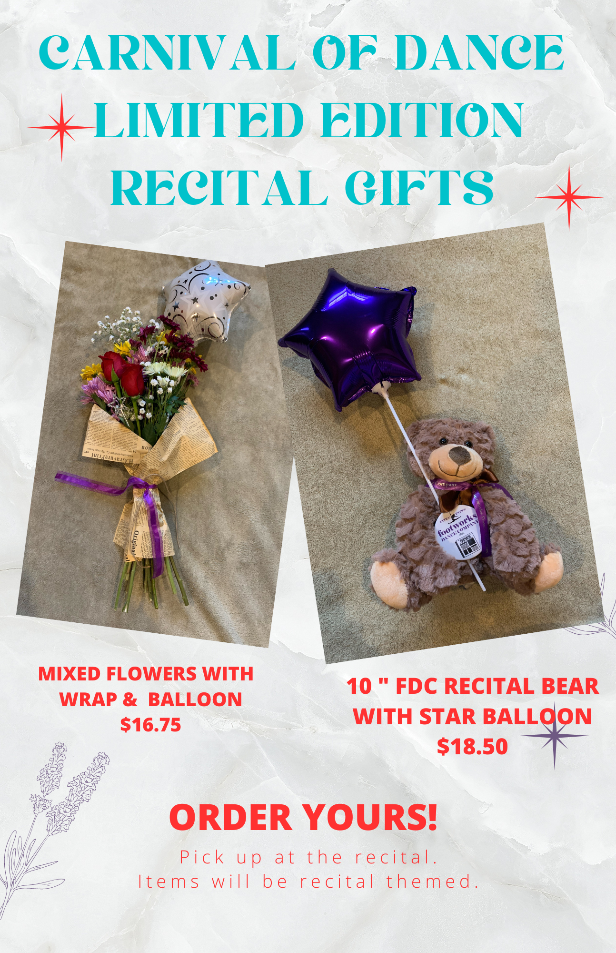
-------------------------------------------------------------------------------------------------------------------------

RECITAL KEEPSAKE GIFTS – PRE-ORDER FORM

QUANTITIY

__________ FLOWERS WITH BALLOON, BUTTON AND WRAP TO MATCH OUR THEME $16.75 EA

__________ KEEPSAKE RECITAL BEAR WITH BALLOON $18.50 EA

__________ CARNIVAL TREAT BOX FILLED WITH TREATS AND A BALLOON $14 EA

DANCER:_____________________________________________________________________

FROM:_______________________________________________________________________

AMOUNT DUE _____________ FDC office use: PAID BY ___ CASH ___ CHECK ___ PLEASE CHARGE THE CARD ON FILE

PRIDE PROGRAM ADS AND BUSINESS ADS

Parents, grandparents, aunts, uncles and friends can purchase space to place a Pride Program Ad in the dance recital program. Pride ads can say anything, but they usually say “Congratulations”, “We love you” or “We are so proud of you”. Please keep it 30 words or less. $15

Business owners, this is the perfect advertising opportunity to share your business with our supportive, wonderful Footworks Community! $39

Use the attached form to submit your pride ad to the front desk or email us at footworksdancecompany@gmail.com.
-----------------------------------------------------------------------------------------------------------------------------------------------------------------

Student Name:________________________________________________________________________

Message:

FROM:_______________________________________________________________________

AMOUNT DUE _____________ FDC office use: PAID BY ___ CASH ___ CHECK ___ PLEASE CHARGE THE CARD ON FILE

